The Mobile Brand Experience:
Measuring Ad Effectiveness on the Mobile Web

by George Pappachen, Safecount and Kara Manatt, Dynamic Logic

This paper describes the pioneering work of conducting ad effectiveness research on the mobile web. By forging a process that combines innovation, collaboration, leadership, and research rigor, a previously unavailable view on branding impact was introduced. The research primarily employs control/exposed methodology and this paper grants an early look at the impact mobile ads have across traditional brand metrics (brand and ad awareness, message association, brand favorability, purchase/behavior intent).

Introduction

This paper outlines a groundbreaking way to measure the branding efficacy of mobile advertising. While it is not novel to recruit panel respondents for mobile research, live recruitment via mobile device is. By employing custom technology in support of the reliable techniques utilized in quantifying Internet campaigns over the past nine years (4,000 studies), a previously unavailable read on branding impact was introduced.

This approach, the control/exposed methodology, has been successfully tested and repeated across a number of mobile studies, allowing for an early look at the impact mobile ads have across traditional brand metrics (brand and ad awareness, message association, brand favorability, purchase/behavior intent). In addition, the approach can provide information on how consumers use their mobile devices, what their mobile web activities and behaviors are, and can deliver insights on target audiences. Especially if coordinated with reach and frequency data, this approach can help shape a fuller understanding of the effectiveness of mobile advertising and the audience it impacts.

Data to be discussed will include early averages across the above mentioned attitudinal measures and comparisons, to what is typically seen on the Internet when using the same methodology and metrics.

Our Research Philosophy: Brands and Advertising

In the minds of a consumer, brands are defined by all its associations – rational and emotional – which generate interest, curiosity, and set up expectations on service or product experience. Good marketing communication is central to ensuring brand success and advertising is a leading communication tool.

Advertising across all platforms creates brand memories that are stored. The more these associations are refreshed, the more permanent they become. Useful branding techniques for effective advertising may include clear symbols to identify the brand and insight into the distinct brand benefits, and promote positive feelings, good social values, and overall desirability.

Will the ad get into the mental workspace (engagement)? Does the ad affect
brand associations in the right way (association)? Do the promoted brand associations make it more desirable at key decision moments (motivation)? These are some of the questions that an effective campaign would deliberately address and utilize to maximize returns.

While there's no magic formula to ensure advertising success, our experience shows that some basic principles should be observed: 1) distinctive creative is always key; 2) the creative idea should be intrinsically linked to the brand and its messages; 3) the communication should evoke a response which can be either rational or emotional and be personally relevant.

A firm foundation in advertising research has formed the basis of our development of solutions to assess the impact of advertising in new and emerging technology platforms including mobile.

The Mobile Landscape
Worldwide mobile ad spending will grow from $2.7 billion in 2007 to $19.1 billion in 2012, according to an eMarketer report released in March of this year. This report also held that marketers are increasingly including mobile media in digital campaigns and that the average price for a mobile marketing campaign more than tripled to $100,000 in 2007.
Mobile content assumes many forms, which include (in order of total usage): SMS/MMS text messages, Wireless Application Protocol (WAP) Internet, downloadable applications, and video. [Figure 1]

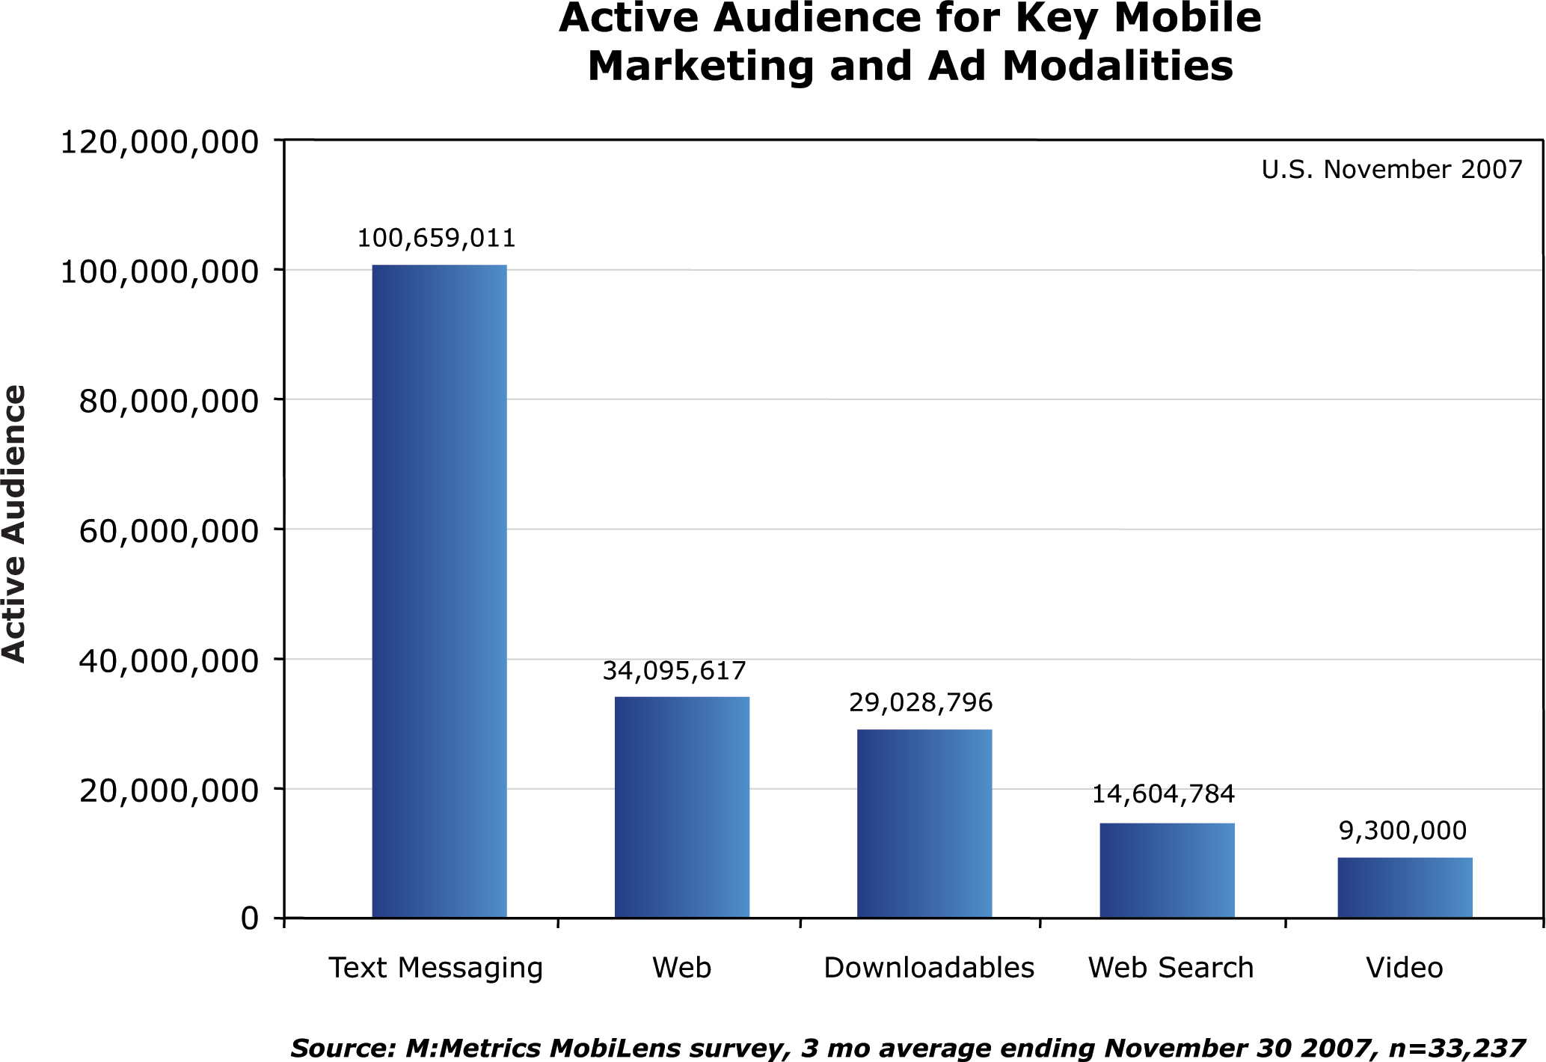

Mobile devices are increasingly gaining foothold in consumer lives and routines. Browsing for movie times, purchasing music and digital content, and interacting on instant messenger are some of the typical entertainment related activities consumers routinely undertake using a cell-phone. [Figure 2]

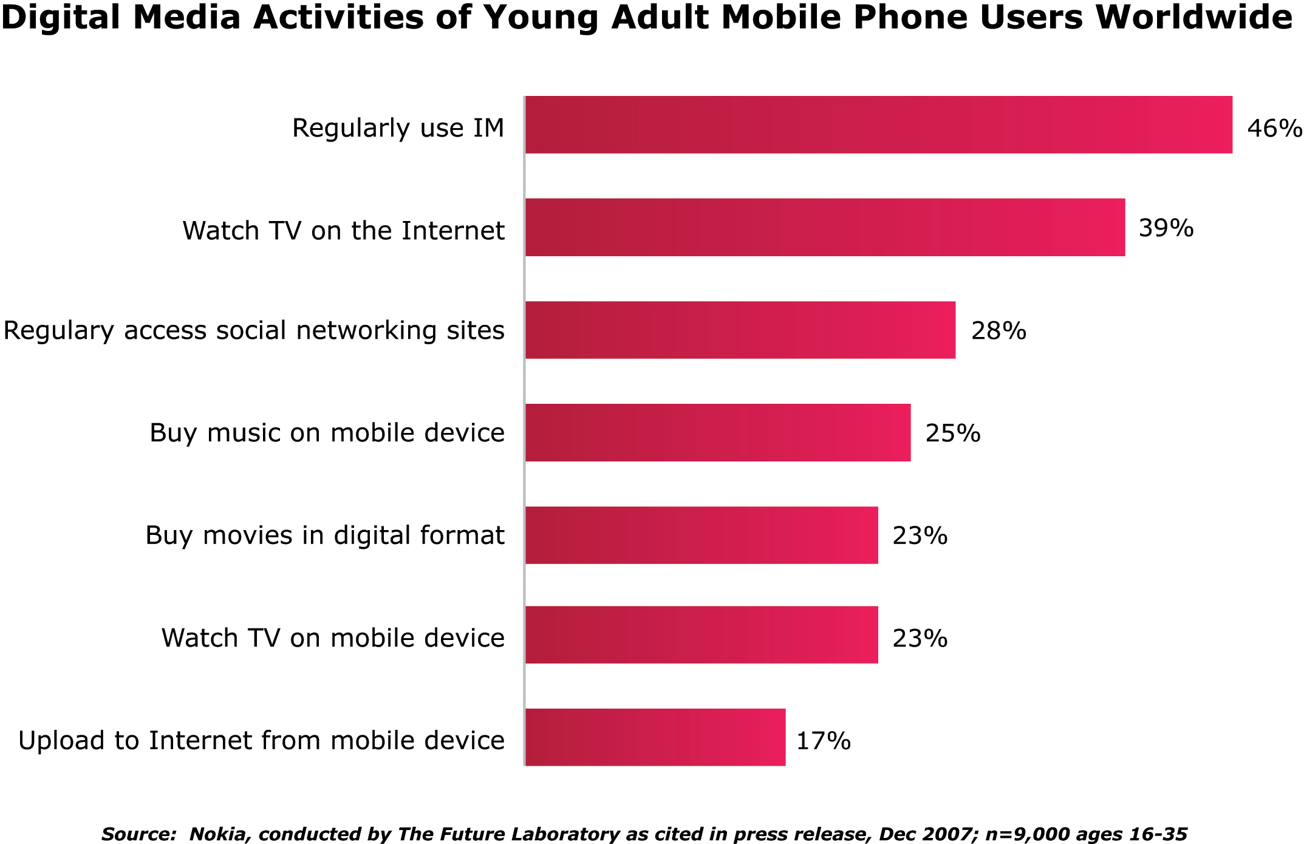

These behaviors reflect growing consumer adoption of the handheld as a legitimate 'third screen' on the road to what optimistic mobile evangelists hope is an eventual battle for 'first screen'' status.

Despite this tremendous growth trajectory, marketers are only now tapping into mobile's vast potential. And while effective mobile campaigns would capitalize on the medium's unique capabilities, marketers predictably expect mobile to offer the Internet's well touted advantages of measurement and accountability. So, part of the process of progressing mobile from exploratory budgets to full fledged contender for media dollars is to determine appropriate metrics for marketing success. In an age of disparate advertising platforms and fragmented media consumption, metrics to evaluate the impact of advertising in the mobile space are critical. Marketers would rightly expect to understand the return on their mobile spend or investment and as well, mobile’s place in the marketing mix. In that vein, this paper reviews the process which enabled survey research to be conducted on a handheld, using a proven methodology that formed the foundation of over 4,000 Internet advertising studies.

This paper seeks to contribute to the understanding of mobile advertising effectiveness in three areas:

- Suggesting standard brand metrics as an evaluative measure for marketing messages on the mobile web.

- Presenting a repeatable, scalable and proven method for measuring mobile advertising effectiveness – AdIndex® for Mobile.

- Providing an early look at how mobile campaigns are performing, with a case study and early mobile averages.

To create a research solution for measuring the effectiveness of mobile advertising, Dynamic Logic adapted its AdIndex methodology, previously employed on the Internet, and applied it to the mobile Web space. [Figure 3]

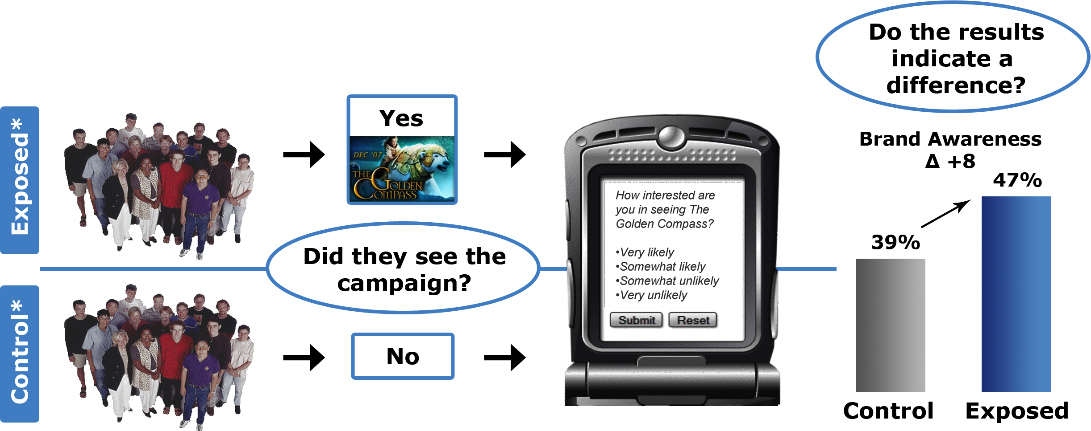

Introducing research on the mobile web, however, had clear technological challenges, such as an inapplicable Internet recruitment model; incompatible Internet survey platforms; non-transferable Internet tracking capabilities; and misaligned mobile ad serving/WAP-site technologies.

The path to progress tackled every technical obstacle with a relentless focus. To be responsible to the still developing mobile ecosystem, respondent interface with the custom mobile survey platform was carefully managed. The rules of engagement were narrowly tailored to fit the unique mobile environment and its distinctive capabilities – industry best practices were strictly observed. The survey platform not only enabled custom integration with differing ad server technologies, but also delivered an innovative results exchange. Partnerships with carriers, ad servers, and other mobile enterprises were negotiated and leveraged to test and trial tracking technologies to identify and separate control and exposed cells. Research on research was conducted to discern handset market penetration and to learn other information on critical technical components of this initiative.

Beyond behavioral measures, such as clicks and view-throughs, AdIndex for Mobile evaluates the impact of mobile advertising on attitudinal measures and, as a result, advances the knowledge of the industry in these key areas:

- Quantifies advertising effectiveness for mobile advertising using traditional brand metrics such as awareness, brand favorability, ad recall, and purchase intent, and compares these metrics from a given campaign back to ad effectiveness averages culled from prior campaigns.

- Enables visibility into the following aspects of user experience and consumer media consumption habits – these elements are selectively incorporated in collaboration with media partners and are customized to study objectives:

  - how consumers perceive and react to mobile advertising

  - optimize mobile advertising placement, reach and frequency levels using consumer-supplied data points

  - identify points in the decision-making process where consumers are most receptive to mobile advertising

  - investigate if mobile complements an advertiser’s marketing mix

Prior to the introduction of AdIndex for Mobile, the research community relied on panel-based approaches and measurement built solely on user recall of mobile advertising. This was not an ideal approach for many reasons — prohibitive cost, inaccuracy of self-reported exposure, and difficulty of recruiting respondents exposed to advertising due to the relatively low reach of mobile campaigns, just to name a few. The solution outlined in this presentation is based on live, in-market measurement of advertising exposure and was designed to deal with these issues.

Methodology: Quantifying Mobile Performance

AdIndex for Mobile uses a control/exposed methodology to gauge the impact of mobile ad campaigns as they run live across WAP site(s). Campaign ads are tracked through either a mobile ad server or by our proprietary AdScout Mobile technology. This tracking allowed for the distinguishing of two cells of mobile users: those who have been exposed to the specific advertising campaign and those who have not been exposed to it. Mobile users are randomly recruited on their mobile device using a banner invitation or text link and are guided to a survey which is taken directly on their mobile device. The survey platform reads from a library of devices and renders optimally to the device in question.

Both the control group and the exposed group are given exactly the same survey and their responses are compared. The survey consists of approximately 10 questions ranging from mobile usage to brand awareness and purchase intent. The basic survey question structure is held consistent across research studies for the purpose of building a normative database for mobile advertising; however, customized questions are developed to measure the specific brand’s attributes or unique campaign messages.

Simultaneous recruitment of control and exposed respondents, controls for outside influences (i.e. seasonality, offline media, etc.) and ensures that the only statistical difference between the control and exposed groups is exposure to the advertising. As a result, any differences in survey responses between the two groups can be attributed to the impact of the mobile advertising. As a standard practice, Dynamic Logic samples 300 control respondents and 300 exposed respondents and uses a two-tailed t-test to determine statistically significant differences. This methodology provides media companies, agencies and advertisers with much needed research to assess the effectiveness of mobile advertising.

An Early Look at Mobile Performance

Early averages from 14 measured mobile ad campaigns across a variety of industries suggest that mobile advertising is a highly effective medium for raising top and bottom funnel brand metrics. [Figure 4]

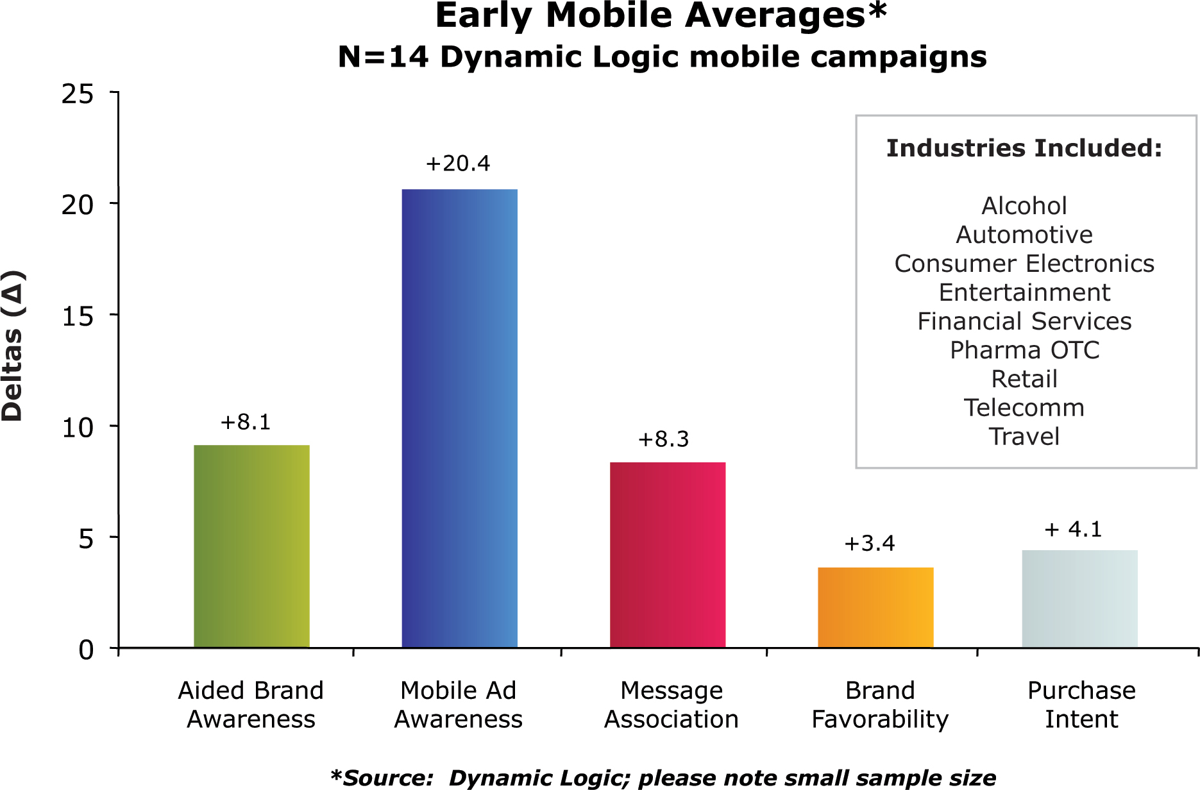

An average increase of +20.4 percentage-points in Mobile Ad Awareness suggests that these campaigns generally cut-through and grab users’ attention. Increases in Brand Favorability and Purchase Intent of +3.4 and +4.1 percentage-points, respectively, support the ability of mobile advertising to significantly change consumers’ attitudes towards a brand and act as a sales vehicle.

Case Study: Mobile Ads for "The Golden Compass" Film Demonstrate

Branding Impact of Mobile Advertising

To generate excitement for its new film, “The Golden Compass”, New Line Cinema commissioned Greystripe, an ad-supported mobile game and application distributor, to launch a marketing campaign. The purpose of the campaign was to engage mobile users in a gaming environment to raise awareness of the film, raise their interest, and ultimately drive movie-goers to the box office. Greystripe commissioned Dynamic Logic’s AdIndex for Mobile to measure the success of the campaign in reaching these goals.

Study scoping revealed that given the technical nature of mobile gaming, the control cell had to be recruited just prior to the start of campaign to ensure adequate recruitment of respondents who had not seen "The Golden Compass" campaign ad. Exposed respondents were recruited from the Greystripe network between November 8 and December 6 of 2007, while the campaign was in-market. Due to the lack of uniform standards for mobile technology in general and for ad serving in particular, some of our early studies reflect a pre-control/exposed testing, as in this case, rather than the typical simultaneous exposed/control testing employed in other campaigns. Respondents for this study were surveyed on their mobile phones about their movie-going habits, awareness of “The Golden Compass” movie, attitudes towards it, and intent to go and see it at a theater.

Results show that the campaign reached an extremely relevant audience. Two-thirds of the sample reported having seen a movie in a theater in the past two months, and about a third use their mobile device to find theaters and movie times, watch movie trailers, and visit movie WAP sites.

The campaign also made an impressive impact in marketing “The Golden Compass” movie. [Figure 5]

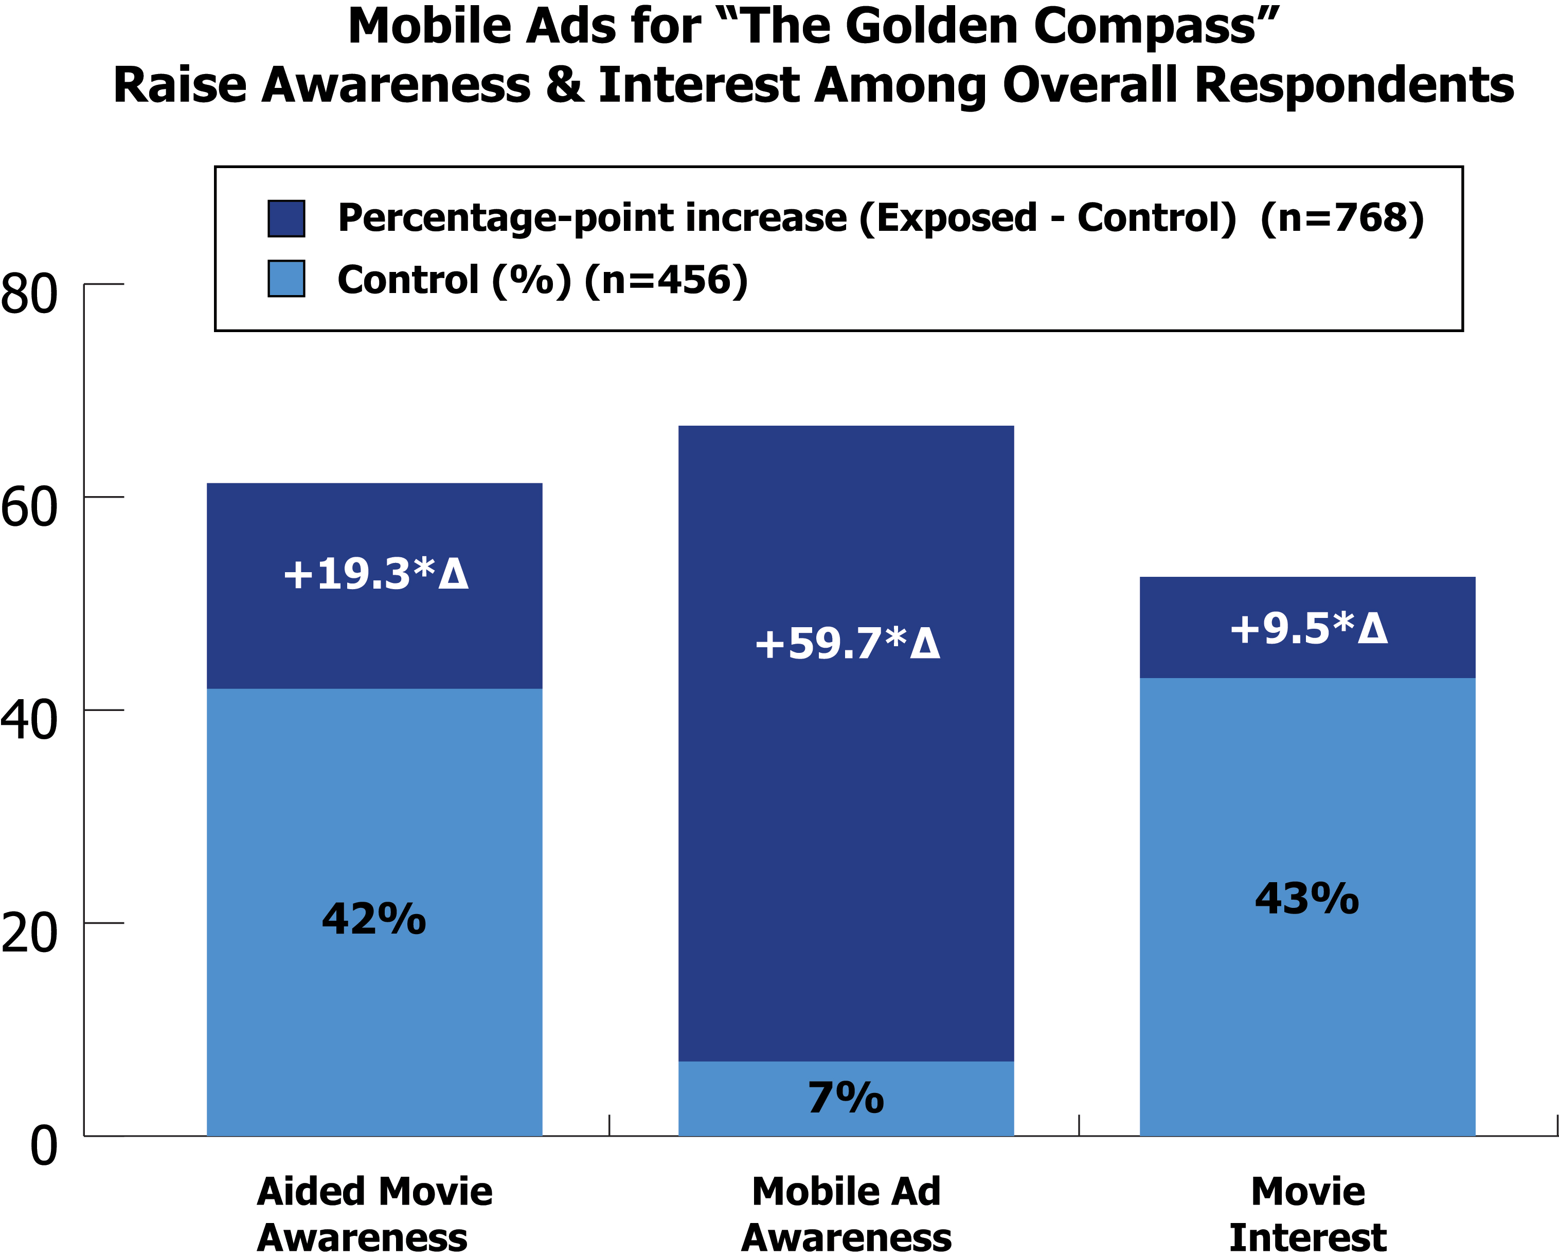

Users exposed to the campaign showed a +19.3 percentage-point increase in awareness of the title and a +59.7 percentage-point increase in awareness of the mobile ad. In terms of shifting attitudes, exposure to the campaign generated a +9.5 increase in Movie Interest. In other words, 9.5% of people who became interested or very interested in the film would otherwise not have been. All three metrics surpassed Dynamic Logic’s early mobile averages for these measures. [Figure 6]

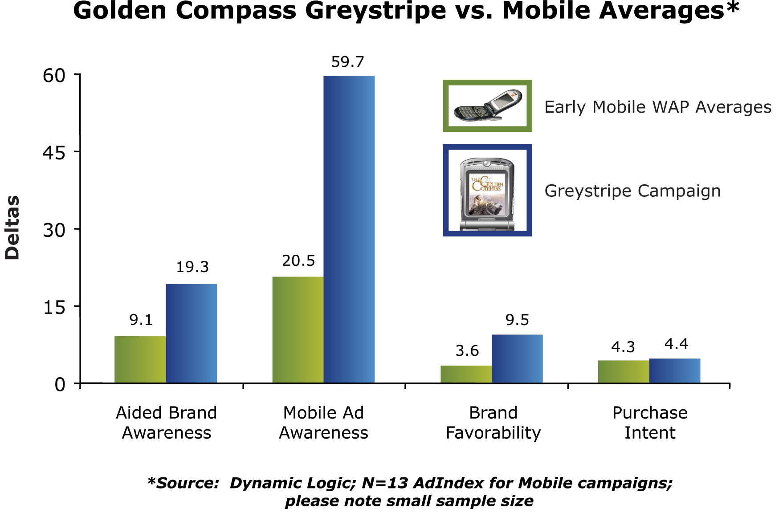

Relevant Messaging is Key

It is no surprise that consumers may be wary of advertising on their mobile devices. This may result in consumers’ rejection of advertising on a device that is considered very personal. It is possible that people may not yet see the value in mobile ads at this stage. The perception may be that ads on mobile phones will be intrusive and interruptive, more like SPAM, so there is an opportunity for advertisers and brands to change this perception by connecting with their audience when the message is relevant.

Relevance is critical to the adoption of mobile advertising. While advertisers are “testing the mobile ad waters” with WAP display formats like banners, the real potential of mobile marketing lies in the mobile marketing efforts that are relevant and offer value to consumers when they want and need it.

Conclusions: Where Do We Go From Here?

While there’s still much to learn, initial research demonstrates mobile advertising campaigns can generate a strong branding impact across a wide range of industries – across low and high-consideration categories. Mobile advertising campaigns have the power to significantly impact top and bottom funnel brand metrics, from brand awareness all the way down to purchasing. In order to provide some context around the brand performance of mobile campaigns (while not an ideal comparison), early mobile averages are higher than those typically seen from similar campaigns on the Internet across most brand metrics (based on Dynamic Logic’s online ad effectiveness database MarketNorms®).

While novelty of medium likely contributes to the higher averages, advertising in a new medium does present an opportunity to influence viewers in a fresh, less-cluttered environment. While it is clear that mobile web is a technology that users are heavily interacting with, differences between mobile and other media may flatten over time as the medium becomes more commonplace. Advertisers should consider leveraging this new medium early on to optimize impact.

Appendix: Measuring Ad Effectiveness on the Mobile Web

References:
du Pre Gauntt, John, (2008), Mobile Advertising: After the Growing Pains, eMarketer: March 2008.

The Authors:

George Pappachen, Director, Market Development, Safecount, United States
Kara Manatt, Research Director, CrossMedia, Dynamic Logic, United States

